Grade 7 Accelerated · Unit 5 · Lessons 2–3  Scale Factor: Perimeter and Area  Question Bank - Additional 5.02 | Name______________________  Date______________________  Period____________________

Show your work. Circle your final answer.
For questions 1 through 4, find the copy's perimeter or area.
1. Perimeter 26 cm, 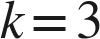.

2. Area 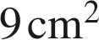, .

3. Area 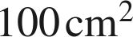, 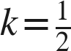.

4. A 4 cm by 5 cm rectangle, 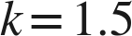. Perimeter and area of the copy.

For questions 5 through 7, find , or the ratio asked.
5. Areas 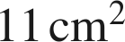 and 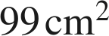. Find .

6. Areas 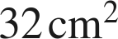 and 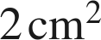, original to copy. Find .

7. Perimeters 10 cm and 50 cm, original to copy. What is the area ratio?

Choose one.
8. A figure with area 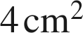 is scaled by 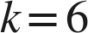. What is the copy's area?
○ A. 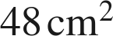
○ B. 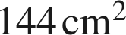
○ C. 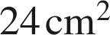
○ D. 